Phil William’s daughter has made a mask for him, he insists it was her who chose the spotty material... The instructions are below the photos.

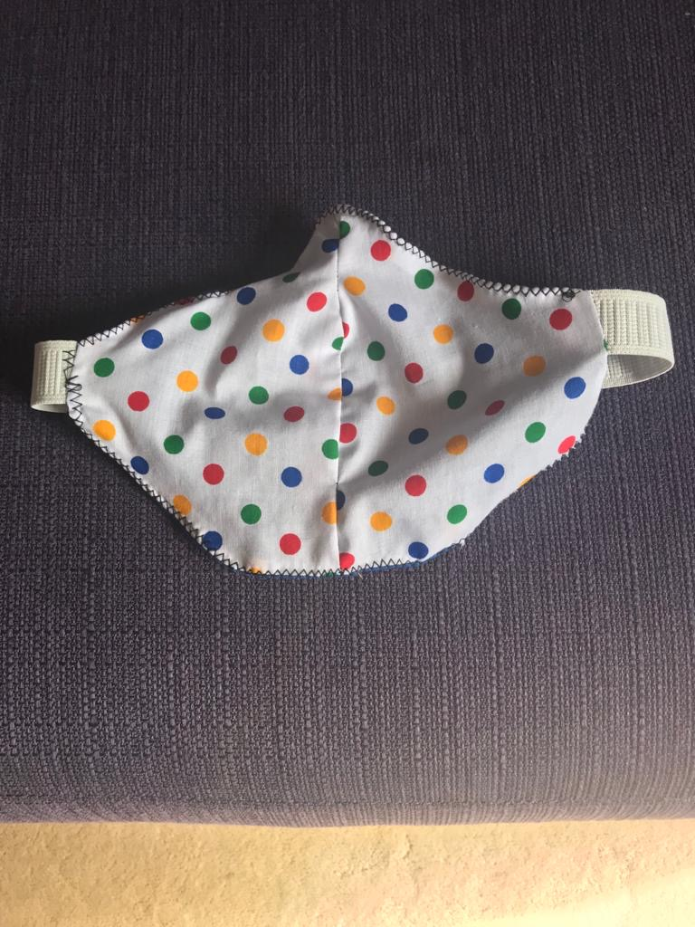 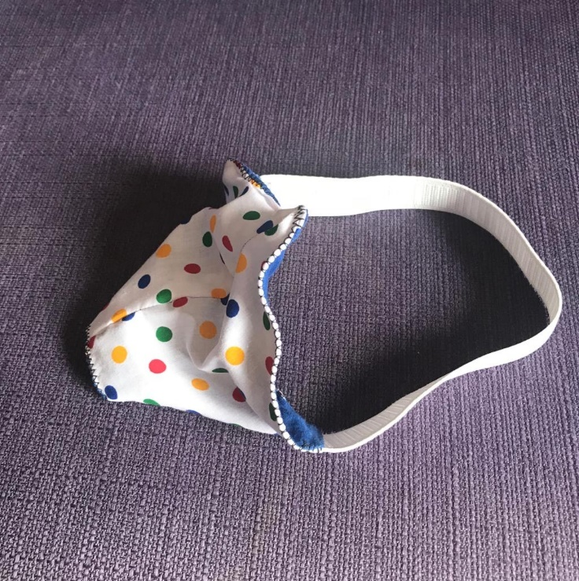

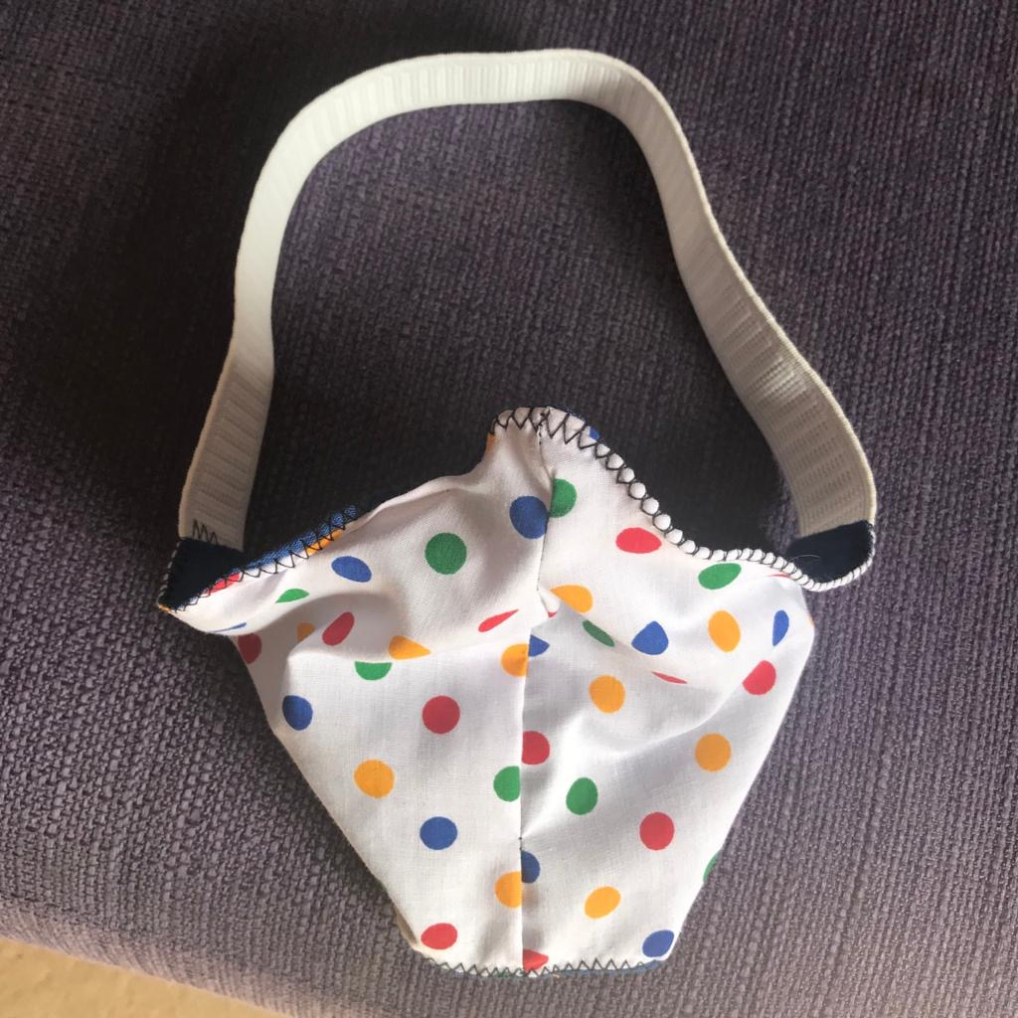

The other side is dark blue. I’m fortunate my arms enable me to reach the strap at the back. But would be easy to ask another to help safely?

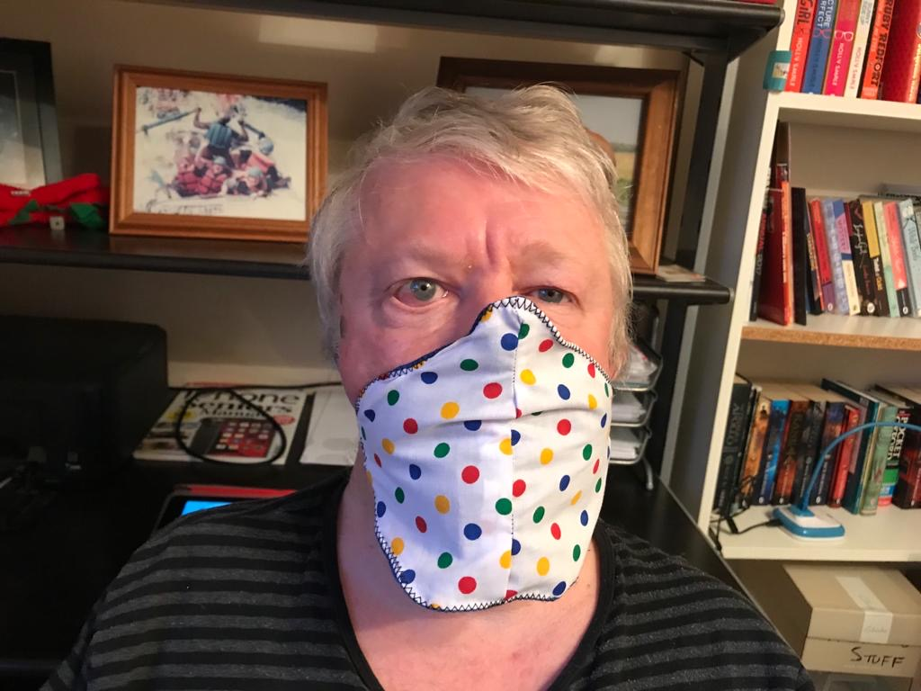

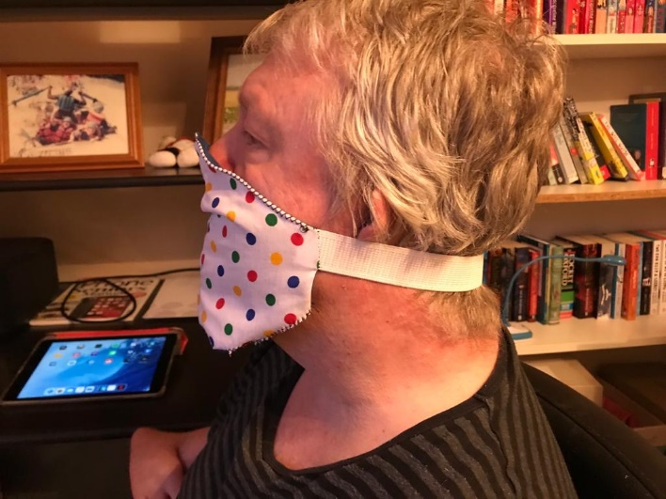 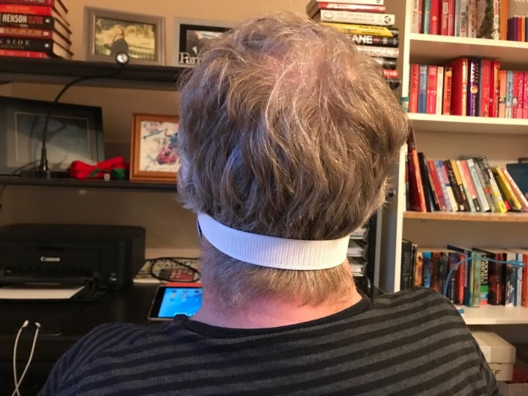

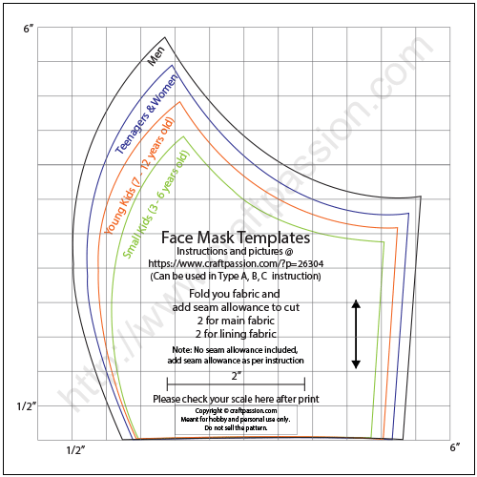

Cut out four pieces of material; either four pieces in the same colour or two in one colour and two in contrasting material.

Join two pieces of the same colour from the point down, leaving the other edges.

Measure to your face and cut to size if needed, also measure and stitch on your elastic.

Repeat with the other two pieces of material.

Put the two pieces with the right sides together and stitch around the edges leaving gaps on both sides.

Turn it the right way round and measure to your face. If you need to do any more adjustments turn inside out to cut and re-sew. Check and repeat until it fits.

Turn it inside out then stitch up one of the holes in the side. Turn the right way round and zig-zag stitch the hole closed and around the entirety of the mask. There are variations on the design here:

<https://www.youtube.com/watch?v=KBR98YKAr7w>

<https://www.craftpassion.com/wp-content/uploads/2013/08/face-mask-pattern-rev3.pdf>